Automated Car Rental Management System in ServiceNow
An Enterprise Fleet Reservation & Automation Solution built on the ServiceNow Platform
Team ID: ______________________
Submitted by: Segabandi Sasidhar
Date: 05 September 2026
Section No. | Section Title / Content Item | Page Reference
1.0 | INTRODUCTION | 1
1.1 | Project Overview | 1
1.2 | Purpose | 1
2.0 | IDEATION PHASE | 2
2.1 | Problem Statement | 2
2.2 | Empathy Map Canvas | 2
2.3 | Brainstorming | 2
3.0 | REQUIREMENT ANALYSIS | 3
3.1 | Customer Journey Map | 3
3.2 | Solution Requirement | 3
3.3 | Data Flow Diagram | 4
3.4 | Technology Stack | 4
4.0 | PROJECT DESIGN | 5
4.1 | Problem Solution Fit | 5
4.2 | Proposed Solution | 5
4.3 | Solution Architecture | 6
5.0 | PROJECT PLANNING & SCHEDULING | 7
5.1 | Project Planning | 7
6.0 | FUNCTIONAL AND PERFORMANCE TESTING | 8
6.1 | Performance Testing | 8
7.0 | RESULTS | 9
7.1 | Output Screenshots | 9
8.0 | ADVANTAGES & DISADVANTAGES | 11
9.0 | CONCLUSION | 12
10.0 | FUTURE SCOPE | 12
11.0 | APPENDIX | 13
11.1 | Source Code (Business Rules & Client Scripts) | 13
11.2 | Dataset Link | 14
11.3 | GitHub & Project Demo Link | 14

1. INTRODUCTION
1.1 Project Overview
The Automated Car Rental Management System is an enterprise transportation solution built natively on the ServiceNow platform that enables employees to book corporate vehicles online through a simple, guided Service Catalog form. Requesters select their scheduled departure date, trip duration, pickup and drop-off locations, car category (Sedan, SUV, Mini), and provide a travel justification. Based on these inputs, client scripts validate departure dates, and Flow Designer orchestrates managerial approval, automated task generation for the transport fulfillment team, and instant email updates. If a vehicle is unavailable or rejected, an After Business Rule automatically generates an Incident ticket for fleet tracking. The solution eliminates manual email booking exchanges, mitigates double-booking, and gives operations teams live visibility into fleet demand via Platform Analytics dashboards.
1.2 Purpose
The purpose of this project is to automate enterprise vehicle scheduling, approvals, and dispatch using ServiceNow Service Catalog, Flow Designer, Catalog Client Scripts, Business Rules, Notifications, and Platform Analytics capabilities, so that:
- Employees can book corporate vehicles at any time through a self-service portal without manual paperwork or unstructured emails.
- Managerial review is integrated into the workflow, holding vehicle fulfillment until formal authorization is granted.
- Approved requests automatically generate Catalog Tasks (SCTASK) for transport fulfillment coordinators with all trip parameters pre-populated.
- Fleet unavailability and rejections automatically trigger Incident records to manage vehicle stockouts systematically.
- Fleet administrators gain real-time visibility into booking statuses and vehicle category popularity via interactive dashboards.
2. IDEATION PHASE
2.1 Problem Statement
Enterprise employees currently rely on unstructured emails, informal messaging, and disconnected spreadsheets to reserve corporate vehicles for business travel, leading to delayed managerial approvals, missing travel parameters, and uncoordinated vehicle handovers. Furthermore, when vehicles are unavailable or requests are rejected, requests stall without auditable incident tracking, leaving transport coordinators without visibility into fleet demand or scheduling bottlenecks.
2.2 Empathy Map Canvas
Persona: Corporate Employee / Business Traveler
SAYS DOCX | THINKS DOCX
"I need to reserve a corporate vehicle for an offsite client meeting tomorrow morning."  "Has my manager approved my car rental request yet?" | "Submitting travel requests shouldn't require manual email threads or physical paperwork."  "I hope the transport department confirms the reservation early so I am not stranded."
DOES | FEELS
Navigates to the Service Portal (/sp), inputs trip dates, locations, car category, and justification, and tracks status via email notifications. | Frustrated by slow email approvals, anxious about vehicle availability at departure time, and relieved when provided with tracked REQ and RITM records.
2.3 Brainstorming
The following ideas were generated during the ideation phase to address the identified problem:
- Self-service car rental booking via the ServiceNow Service Portal (/sp).
- Client-side validation scripts to enforce future departure dates and valid duration limits.
- Automated multi-step Flow Designer workflow initiating upon catalog order submission.
- Mandatory managerial approval routing before dispatching fleet resources.
- Automated Catalog Task (SCTASK) generation assigned to the Transport Fulfillment Team upon approval.
- Automated outbound system email notifications updating requesters on approval status.
- Server-side After Business Rule to auto-generate Incident tickets when requests are marked unavailable or rejected (State == 3).
- Real-time Platform Analytics Dashboard featuring Donut and Bar charts to track fleet utilization.
3. REQUIREMENT ANALYSIS
3.1 Customer Journey Map
Stage DOCX | Passenger / Employee Action DOCX | System Response DOCX | Requester Experience DOCX
1 | Discover Service | Opens Service Portal (/sp) and navigates to Car Rental Request under Services. | Curious, exploring
2 | Fill Booking Form | Enters departure date, pickup/drop locations, duration, car type, and justification. | Engaged, clear inputs
3 | Validate Inputs | Client script verifies future departure date and validates numeric duration. | Reassured, prevented from errors
4 | Submit Request | Clicks Order Now; system generates linked REQ and RITM records. | Confident, receives tracking numbers
5 | Manager Review | Flow Designer routes request to line manager for approval. | Hopeful for quick approval
6 | Task & Confirmation | Upon approval, system auto-creates SCTASK for transport and sends approval email. | Delighted by instant notification
7 | Trip & Exception Handling | Handover occurs; if vehicle is unavailable, an Incident is auto-created for resolution. | Supported and unhindered
3.2 Solution Requirement
Software Requirements:
- ServiceNow instance (Personal Developer Instance dev428737)
- Service Portal plugin enabled (sp_portal)
- Workflow Studio / Flow Designer active (Car Rental Req)
- Email Notification engine and SMTP outbound logging (sys_email)
- Business Rules engine (server-side GlideRecord automation)
- Scoped Application Architecture (x_1894596_car_re_0)
- Modern web browser (Chrome, Edge, Firefox)
Hardware Requirements:
- Standard desktop or laptop computer
- Minimum 4 GB RAM (8 GB recommended)
- Stable internet connection
3.3 Data Flow Diagram
Level 1 Data Flow Diagram - Car Rental Booking

[ Employee / Requester ] ────(1. Itinerary Inputs)────> [ 1.0 Enter Request ]
│
(Trip Parameters)
▼
[ 2.0 Client Validation ]
│
(Validated Order)
▼
[ 3.0 Submit Order Now ]
│
┌─────────────────────────────────┴────────────────────────────────┐
▼ ▼
[ D1: REQ / RITM Records ] [ D2: Custom CRR Table ]
│
(Trigger Context)
▼
[ 4.0 Ask For Approval ] ──────────> [ D3: sysapproval_approver ]
│
┌──────────────┴──────────────┐
▼ ▼
( Approved ) ( Rejected / Unavailable )
│ │
├─────────────────┐ ▼
│ │ [ 6.0 Business Rule Exception ]
▼ ▼ │
[ 5.0 Create SCTASK ] [ 7.0 Email ] ▼
│ │ [ D4: incident Records ]
▼ ▼
[ D5: sc_task ] [ D6: sys_email ]
│ │
▼ ▼
[ Transport Team ] [ Requester Notice ]
Figure: Level-1 Data Flow Diagram of the Car Rental Booking process
3.4 Technology Stack
Layer DOCX | Technology Used DOCX
Presentation / Frontend | ServiceNow Service Portal (/sp), Service Catalog Form UI
Application / Logic | Catalog Client Scripts (JavaScript ES6, g_form), Catalog UI Policies
Automation / Orchestration | Flow Designer (Car Rental Req workflow engine)
Data Storage | Custom table x_1894596_car_re_0_car_rental_request (CRR prefix) and platform tables (sc_req_item, sc_task, incident)
Security | Scoped Application Access and Access Control Lists (ACLs)
Exception Handling | After Business Rule (server-side GlideRecord('incident') script)
Notifications | ServiceNow Outbound Email Engine (sys_email)
Analytics & Reporting | Platform Analytics Workspace (interactive Donut and Bar charts)
4. PROJECT DESIGN
4.1 Problem - Solution Fit
Manual, spreadsheet-driven vehicle booking creates approval bottlenecks, missing destination details, and untracked cancellations when cars are out of stock. The Automated Car Rental Management System fits this problem directly: it provides a standardized catalog intake on the Service Portal, enforces client-side date validation, automates manager approval routing and task dispatch via Flow Designer, and automatically logs Incidents for stockouts via Business Rules—removing administrative overhead while providing full operational auditability.
4.2 Proposed Solution
S.No. DOCX | Parameter DOCX | Description DOCX
1 | Problem Statement | Enterprise employees rely on manual emails and spreadsheets for vehicle booking, leading to delayed approvals, lost travel details, and zero tracking for vehicle shortages.
2 | Idea / Solution Description | A scoped ServiceNow solution integrating Service Catalog intake, Flow Designer approvals, automated Catalog Tasks (SCTASK), Business Rule exception incident logging, and Platform Analytics.
3 | Novelty / Uniqueness | Native scoped application architecture (x_1894596_car_re_0) unifying self-service intake, approval governance, task fulfillment, automated incident creation for rejections, and live analytics without third-party software.
4 | Social Impact / Satisfaction | Prevents employee travel delays, ensures auditable corporate vehicle allocation, cuts paper requisition waste, and reduces transport coordination effort.
5 | Business Model | Internal shared-services administrative cost savings for corporate fleets; packageable as a certified enterprise fleet management app on the ServiceNow Store.
6 | Scalability of the Solution | Scalable to multiple regional hubs and fleet types; future scope includes GPS telematics APIs, mobile agent task management, and ERP expense integration.
4.3 Solution Architecture
The solution architecture bridges corporate travel intake with a ServiceNow-native technical implementation spanning the Service Portal (presentation), Catalog Client Scripts and UI Policies (application/logic), Flow Designer and Business Rules (automation/orchestration), and custom tables secured by ACLs (data).
Automated Car Rental Management - Solution Architecture

[ User Layer ] ──────────────> [ Employee / Requester (End User) ]
│
▼
[ Presentation Layer ] ──────> [ Service Portal: 'Car Rental Request' Catalog Item ]
│
┌───────────────┴───────────────┐
▼ ▼
[ 6 Catalog Variables ] [ Date Client Script ]
│ │
└───────────────┬───────────────┘
│ Submitted Request (REQ/RITM)
▼
[ Application / Logic ] ─────> [ Flow Designer: 'Car Rental Req' Engine ]
│
┌───────────────┴───────────────┐
▼ (Approved) ▼ (State == 3)
[ SCTASK Fulfillment Task ] [ After Business Rule ]
│ │
▼ ▼
[ Outbound Email Notice ] [ Auto-Created Incident ]
│
▼
[ Data Layer ] ──────────────> [ Custom Table: x_1894596_car_re_0_car_rental_request ]
│
├──────────────> [ Role-Based ACLs ]
▼
[ Platform Analytics Workspace Dashboards ]
Figure: Solution architecture and data flow of the Automated Car Rental Management System in ServiceNow
5. PROJECT PLANNING & SCHEDULING
5.1 Project Planning
Stakeholders identified: Corporate Requesters (employees), Line Managers (approvers), Transport Fulfillment Team (dispatchers), and ServiceNow Administrators.
The project was executed across 5 phases following the milestone roadmap below:
Phase DOCX | Title DOCX | Key Activities DOCX | Progress DOCX
Phase 1 | Requirement Analysis & Planning | Business Objectives, Scope Definition, Stakeholder Personas, Roadmap Planning | 100%
Phase 2 | Backend Development & Configurations | Custom table creation (x_..._car_rental_request), CRR auto-numbering, Business Rule logic | 100%
Phase 3 | UI/UX Development & Customization | Service Catalog item creation, 6 variables, date validation client scripts, portal form layout | 100%
Phase 4 | Data Migration, Testing & Security | Flow Designer workflow (Car Rental Req), Manager Approval gate, SCTASK allocation, ACL security | 100%
Phase 5 | Deployment, Documentation & Presentation | Update set packaging (Complete), Platform Analytics dashboard, documentation, demo video | 100%
Execution Roadmap (Milestones):
Form Intake Setup $→$ Date Validation Script $→$ Approval & Task Flow $→$ Exception Business Rule $→$ Analytics Dashboard $→$ Update Set Packaging & Deployment
6. FUNCTIONAL AND PERFORMANCE TESTING
6.1 Performance Testing
Data integrity and functional checks performed:
- Enforced mandatory variables (requested_date, pickup_location, drop_location, duration, car_type, reason) preventing incomplete form submissions.
- Implemented onChange Catalog Client Script preventing selection of past departure dates.
- Configured Flow Designer engine to dynamically pass catalog variables directly into generated Catalog Tasks (SCTASK).
- Automated exception incident generation via an After Business Rule when request state equals 3.
Debugging and issue resolution:
- Used Flow Designer Execution Details to trace data pills, monitor managerial approval decisions, and confirm green checkmarks on all 4 actions.
- Verified outbound notification records in sys_email.list to confirm message generation in send-ready status.
- Verified scoped Update Set Car Rental Management to ensure all custom metadata was captured without conflicts.
- Validated Platform Analytics dashboard widgets to ensure Donut and Bar charts reflect active table records.
Functional Test Cases:
Test ID DOCX | Test Scenario DOCX | Expected Result DOCX | Status DOCX
TC01 | Open Car Rental Request catalog item | Form renders with all 6 mandatory variables | Pass
TC02 | Select a past departure date | Client script blocks invalid date and alerts user | Pass
TC03 | Submit completed booking via Order Now | Generates Request (REQ) and Item (RITM) records | Pass
TC04 | Manager reviews approval record | Approving advances workflow; holds until sign-off | Pass
TC05 | Verify task generation upon approval | Auto-creates SCTASK0010001 with trip variables | Pass
TC06 | Outbound notification generation | Email logged with subject "Your Car Request is approved" | Pass
TC07 | Request rejected or unavailable (State == 3) | After Business Rule auto-creates Incident record | Pass
TC08 | Access Platform Analytics Dashboard | Real-time Donut and Bar charts display live request counts | Pass
7. RESULTS
7.1 Output Screenshots
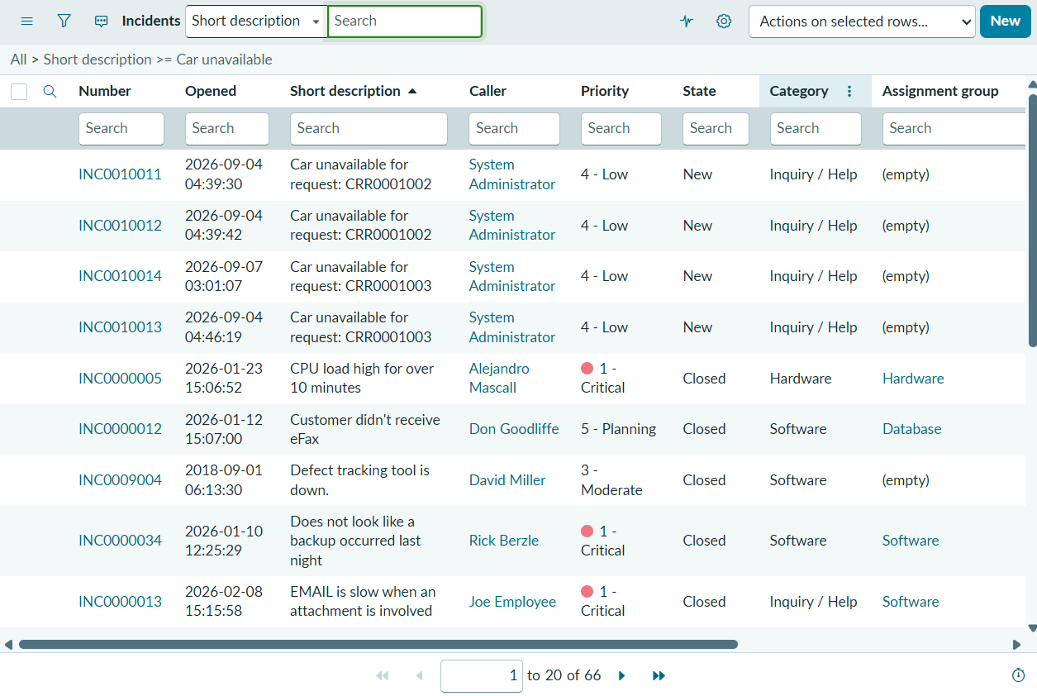
Fig 7.1: Automated Incident creation output (incident.list) showing tickets INC0010011–INC0010014 auto-created by the Business Rule when requests were rejected.
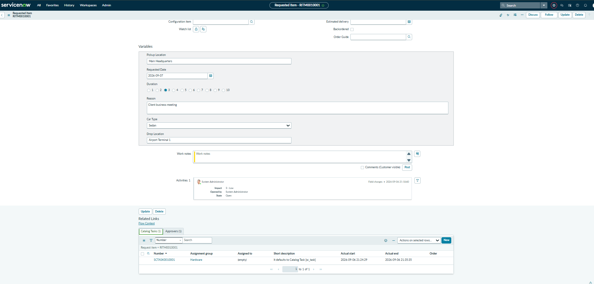
Fig 7.2: Requested Item record RITM0010001 displaying captured catalog variables and generated fulfillment task SCTASK0010001 in the related list.
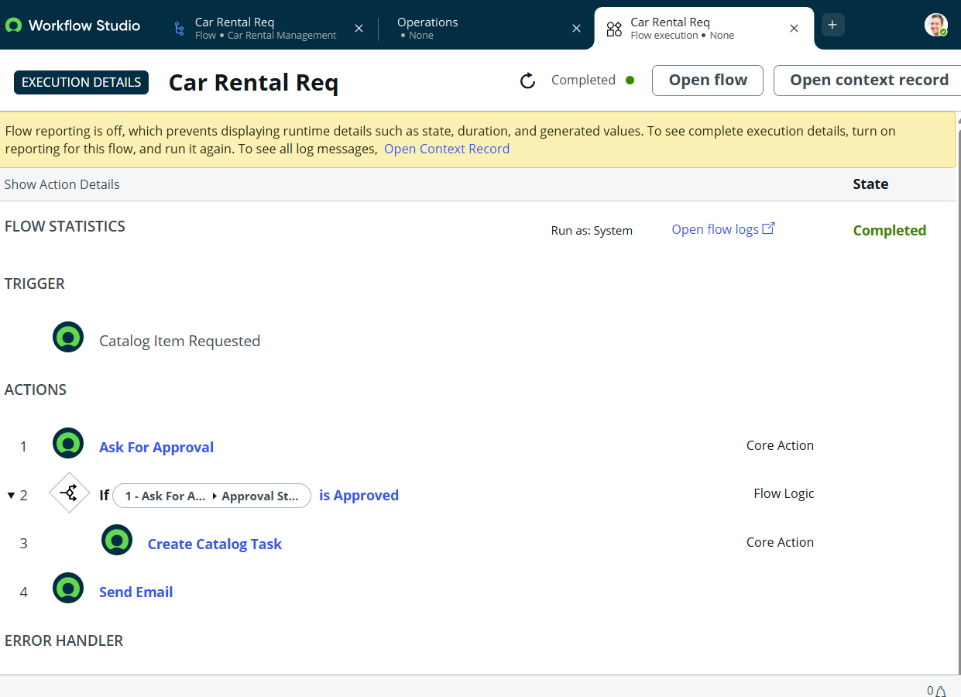
Fig 7.3: Workflow Studio Execution Details for Car Rental Req showing the trigger, manager approval, task generation, and email dispatch completed with green checkmarks.
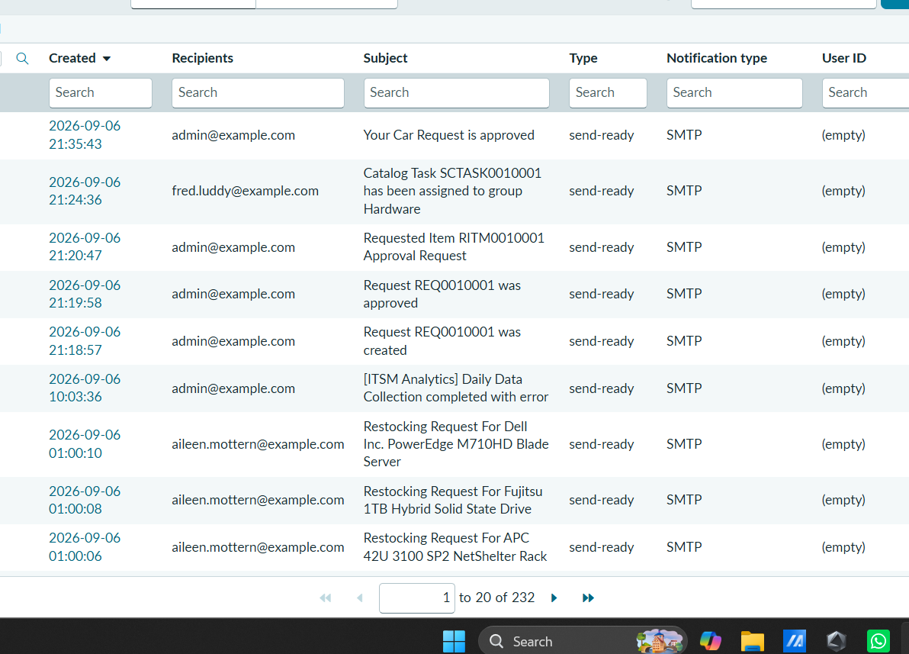
Fig 7.4: System email log (sys_email.list) confirming dispatch of approval notification "Your Car Request is approved" in send-ready status.
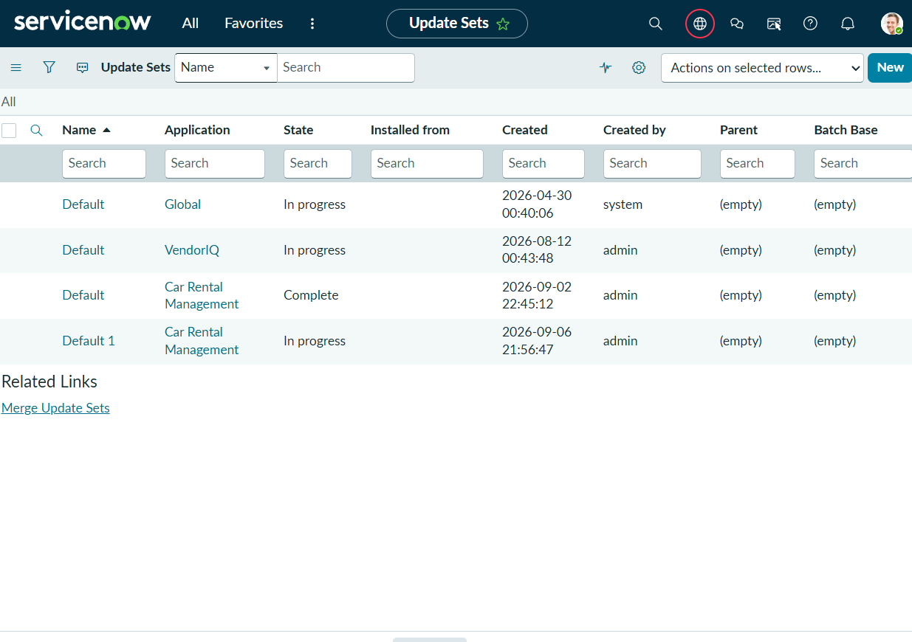
Fig 7.5: Scoped Update Set Car Rental Management marked in state Complete, sealing all application metadata for deployment.
Fig 7.6: Car Rental Management Dashboard in Platform Analytics showing live Donut Chart (Requests by State) and Bar Chart (Requests by Car Type).
8. ADVANTAGES & DISADVANTAGES
Advantages
- Eliminates manual email chains and phone requests, providing a unified Service Portal intake.
- Enforces managerial approval governance to control corporate travel expenditures.
- Automates fulfillment by instantly routing SCTASK records with itinerary details to transport coordinators.
- Features automated exception management that creates Incident tickets whenever vehicles are unavailable.
- Centralizes fleet utilization intelligence through real-time Platform Analytics dashboards.
- Packaged within a clean, scoped Update Set (x_1894596_car_re_0) ensuring conflict-free migration.
Disadvantages
- Currently operates within the ServiceNow developer instance without live outbound SMTP relay to external personal email boxes.
- Vehicle allocation requires manual assignment confirmation by transport coordinators on SCTASK rather than automated telematics dispatch.
- Requires active internet connectivity and platform access to log requests.
- Advanced fleet telematics (live GPS tracking, fuel monitoring) are not yet integrated via REST APIs.
9. CONCLUSION
The Automated Car Rental Management System delivers an auditable, automated enterprise solution on the ServiceNow platform. By transitioning vehicle booking from manual email correspondence to a structured workflow—spanning Service Portal intake, client-side date validation, Flow Designer approvals, catalog task dispatch, automated incident exception logging, and platform analytics—the application removes operational bottlenecks and prevents unfulfilled travel requests. The system provides a solid, extensible foundation for enterprise corporate transportation management.
10. FUTURE SCOPE
The current solution can be extended in the following directions:
- Telematics & GPS REST API Integration: Connect with commercial vehicle tracking systems to capture real-time odometer readings, fuel consumption, and GPS locations.
- Mobile Agent App Workflows: Enable transport coordinators to conduct vehicle inspections, log odometer values, and obtain digital signatures via the ServiceNow Mobile Agent app.
- Performance Analytics (PA): Implement advanced indicators tracking average approval turnaround times, driver allocation velocity, and idle vehicle percentages.
- ERP Travel Expense Integration: Integrate with corporate financial systems (e.g., SAP, Oracle) for automated departmental cost charging.
11. APPENDIX
Source Code (if any)
1. After Business Rule - Incident Auto-Creation on Rejection/Unavailability:
JavaScript
(function executeRule(current, previous /*null when async*/) {
if (current.state == 3) { // State 3 represents Rejected / Unavailable
var inc = new GlideRecord('incident');
inc.initialize();
inc.short_description = 'Car unavailable for request: ' + current.number;
inc.description = 'Car not available for reservation on ' + current.requested_date;
inc.category = 'Inquiry / Help';
inc.priority = 4; // Low priority
inc.insert();
}
})(current, previous);
2. Catalog Client Script - Departure Date Validation (onChange):
JavaScript
function onChange(control, oldValue, newValue, isLoading) {
if (isLoading || newValue == '') {
return;
}
var selectedDate = new Date(newValue);
var today = new Date();
today.setHours(0, 0, 0, 0);

if (selectedDate < today) {
g_form.showFieldMsg('requested_date', 'Departure date must be today or a future date.', 'error');
g_form.setValue('requested_date', '');
}
}
Dataset Link
Not applicable – the project operates on ServiceNow custom application tables (x_1894596_car_re_0_car_rental_request) and core platform tables (incident, sc_task, sc_req_item) populated directly within the instance rather than relying on external flat datasets.
GitHub & Project Demo Link
- GitHub Repository: ______________________________________
- Project Demo Video: https://drive.google.com/file/d/1QrXKw4F466TesOmQvm0rlMnQKAzjmPIy/view?usp=sharing

